**COMSATS University Islamabad, Lahore Campus**

**Subject :** Object Oriented Programming

**Assignment :** Lab Task

**Submitted To :** Sir Shahid Bhatti

**Submitted By :** Muhammad Waqar

**Registration No :** SP24-BSE-091

**Section :** A

***Data Entry Form***

**Enter Your Data in the Text Fields**

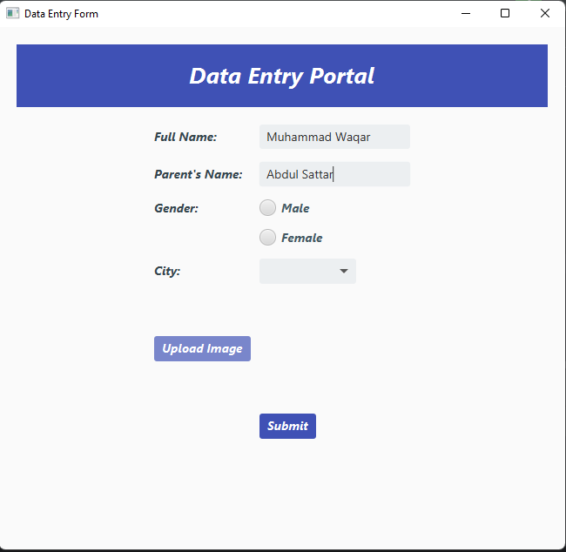

**File Chooser**

**Submit Button**

**Combo Box**

**Text Field**

**Radio Button**

**Labels**

**Select your Gender Using Radio Button and city using Combo Box**

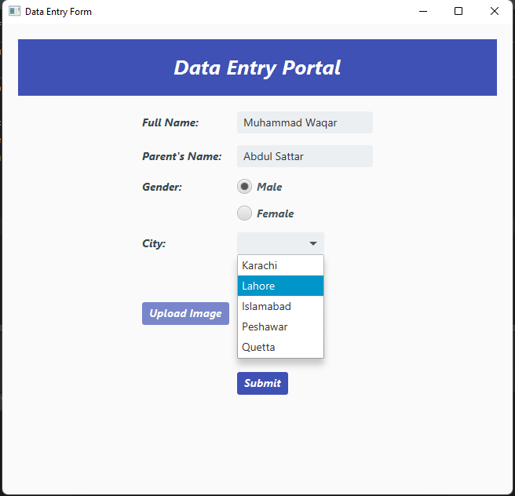

**Click on Upload Image to Select Image**

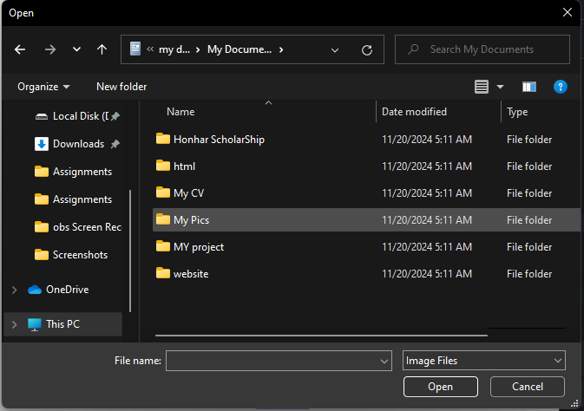

**Click on Submit Button for New Scene**

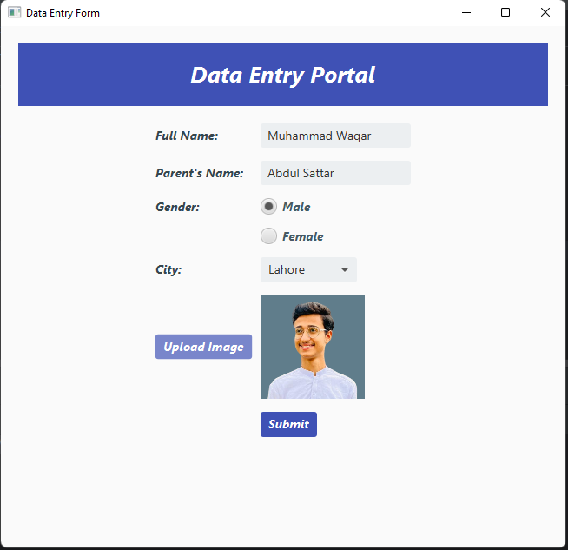

New Scene Appears

